**Stakeholders of Data-Driven Venture Capital: Startup Ecosystem Analytics Engine Project**

**Section 1 – Identifying Stakeholders**

|  |  |  |  |  |  |
| --- | --- | --- | --- | --- | --- |
| **Stakeholders** | **What do they do?** | **Interaction** | **Expectation** | **Owner** | **Priority** |
| **Main Sequence Venture Capital** | Find the potential start-up technology company and get substantial returns | Manage funds of CSIRO | Practical tools for analyzing data | Jiale Wang | High |
| Data Security | Jiale Wang | High |
| **Client (Stella Xu)** | Analyze which company is worth to invest by relevant data | Employee of MSVC | Query and update data | Jiale Wang | High |
| Better presentation for various of data types | Jiale Wang | Medium |
| **CSIRO** | Provide funds for Australia technology company | Sponsor | Fund feasible project | Xing Meng | High |
| Ensure the acceptable returns | Yafei Liu | Medium |
| **TechPioneer (Project Team)** | Construct a tool for MSVC to analyze data | Follow client’s requirement to work | Functional database | Xufeng Zhu | High |
| Good interface for users | Weikai Lu | Medium |
| Steady connection between database and interface | Zihang Wei | High |
| **ANU** | Provide the opportunity for client and students to work together | intermediary | Observe school discipline. | Heyi Xiong | Low |
| Safety. | Heyi Xiong | High |
| **Lecturer, tutor** | Provider instructions on many aspects | Instructor | Improve as their advises | Zihang Wei | High |
| **Shadow Team** | Provide feedback | Judge | Obtain outcome on time | Zihang Wei | Low |

After our group discussion, according to who was the beneficiaries, the sponsors, the influencers, and sponsors are for data-driven venture capital: startup ecosystem analytics engine project, we analyzed the following stakeholders (see below Figure 1). It is easier to recognize stakeholders, and the harder is to analyze some stakeholders' requirements or expectations. We start by breaking each person's needs or expectations into smaller, single needs. This not only gives us a clearer picture of what they want, but it also allows us to avoid missing other, less obvious needs.

**Figure 1**

According to each person's personality and technical expertise, we have assigned the team member in charge of each requirement. The owner is both a monitor and a participant, and other team members may also be participants in this requirement. The person in charge is responsible for controlling the schedule and quality of the requirement.

**Section 2 – Determining the expectation priority**

To ensure that the team properly addresses their needs and expectations and understands the impact of stakeholders on the project, our team needs to prioritize them. According to Burke (2010), our group uses the Power/Interest Grid Theory to rank the expectations of stakeholders (see below Figure 2).

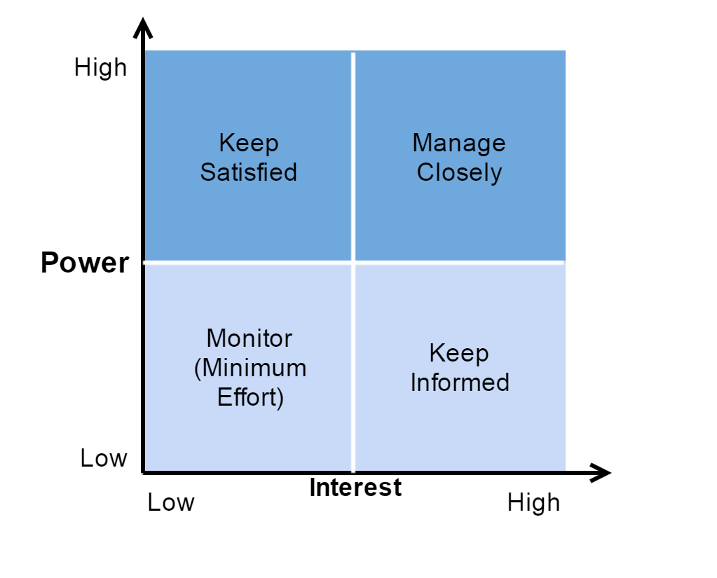

**Figure 2**

Our team adjusted the order of each expectation based on this classification method.

**Section 3 – Communication Strategy**

Since we are all Master of Computing students, we all follow the computer science personnel guidelines strictly under the SFIA 7 specification (see details at https://www.sfia-online.org/en/sfia-7). In addition, we will follow the rules of ANU and COMP8715 to communicate.

According to Figure 2, we developed a part of the communication strategy. The more in the upper right corner, the more it needs to communicate in a timely manner, giving priority to meeting their needs. While the bottom left corner does not mean we do not need to communicate, it just prevents them from getting bored with too much contact.

In addition, we use nontechnical language when we communicate with non-technical people so that they can understand what we are doing. When communicating, pay attention to key stakeholders and we will not ignore the secondary stakeholders. If bad news appears in the project, do not hide the fact, and communicate with stakeholders, especially client and tutor, in a timely manner.

Our meeting records with various stakeholders will be written into the Stakeholder Engagement folder (see at <https://github.com/wjiale960224/Data-driven-Venture-Capital-startup-ecosystem-analytics-engine/tree/master/Stakeholder%20Engagement>).

These are preliminary ideas discussed by the team and will change as the project progresses.

**Reference List**

Burke, R. (2010). *Fundamentals of project management: Tools and techniques.* Ringwood: R. Burke.